**A comparative study of social-economic factors and government implemented policies between countries on the transmission of coronavirus disease (COVID-19)**

**Abstract**

The outbreak of the novel coronavirus, COVID-19, has been declared a pandemic by WHO. Social contact critically determines the spread of the infection and, in the absence of vaccine or effective treatment, the rapid spread of this disease elicited a wide range of large-scale social distancing measures from different governments across the globe as the most effective means of mitigating COVID-19. Here, we employed growth-curve models (Logistic, Bertalanffy and Gompertz models) for cumulative confirmed cases available daily from forty countries around the world to analyze the relationship between these models' summary statistics and country's development status using factors like life expectancy, GDP, urbanization, etc on the spread of COVID-19.

and trajectory analysis to analyze the available daily new cases of the COVID-19 outbreaks of forty countries around the world. We investigated the relationship between the transmission dynamics of the pandemic and the development status of a country as an indicator of selected variables like GDP, urbanization, life expectancy, etc. Also, we tested incorporated governments’ intervention (school closure, workplace closing, close public transport, income support, contact tracing, etc.) in mitigation of COVID-19 using the Generalized Estimation Equation (GEE) model. Our analysis found that a country’s population, social-economic and healthcare infrastructures have both weak and strong significant relationships with transmission dynamics of COVID-19 for all the indicator variables used. Developed countries tend to take long time before we see an increase in the number of daily confirmed cases but after that, the expansion rate is rapid among the population. Out of the 17 policies analyzed, closure of public transport, international travel controls and contact tracing are the only policies found to have significant impact in the control of numbers of daily confirmed cases.

1. **Introduction**

A number of unexplained pneumonia cases have been successively discovered in Wuhan, Hubei, China, in early December 2019, which have been confirmed to be severe acute respiratory syndrome caused by a novel coronavirus 2 (SARS-CoV-2), and has spread rapidly across the globe.1 The spread of coronavirus disease 2019 (COVID-19) has become a global threat and the World Health Organization (WHO) declared COVID-19 a global pandemic on March 11, 2020.2  As of July 6, 2020, there were a total of 11,556,61 confirmed cases and 536,776 deaths from COVID-19 worldwide.3

The COVID-19 pandemic has been greatly affecting people’s lives and the world’s economy. In the absence of vaccine or effective treatment, the rapid spread of this disease elicited a wide range of responses from different governments across the globe to curb the spread of COVID-19. Common measures include school closings, travel restrictions, bans on public gatherings, stay at home orders, closure of public transportation, emergency investments in the healthcare system, new forms of social welfare provision, contact tracing, etc.9 The suppression of social contact in workplaces, schools and other public spheres is the target of such measures.4-6 Specifically, governments are adopting these policies hoping they will reduce the amount of person-to-person contact in the population. In theory, reducing the frequency of contact means that there will be fewer opportunities for the virus to pass from one person to the next.20 Evidence from microsimulation models suggests that these interventions will decrease the size of the epidemic and redistribute the number of cases over time20-21, reducing the risk that local health care systems willbe overwhelmed by surges in demand for health services20.

Also many papers have already been published showing the effectiveness of different implemented government policies in the mitigation of COVID-19 pandemic. Prem and Lui *et al.,* (2020) used the deterministic stage-structured SEIR model to show the positive effects of extended workplace distancing, reduction in mixing in community and school closure to control pandemic situation in Wuhan.14 Zhang, Ma and Wang (2020) used segmented Poisson model to predict turning point, duration and attack rate of COVID-19 in major western countries while measuring the effects of implemented policies in those countries.4 Rajesh Singh and R. Adhikari (2020) used the mathematical SIR model to show the importance of “Janata curfew”, lockdowns and workplace non-attendance used in India to curb the pandemic.5 Qui and Chen *et al*.,(2020) used 2SLS machine learning model to examined the role of various socioeconomic factors in mediating local and cross-city transmission of coronavirus in China. All these proved the importance of government policies implemented in the control of the pandemic by governments.

However, the effects of these fast-changing policies in the mitigation and control of COVID-19 have not been measured. In this paper, we present growth-curve based models and Trajectory based analysis carried out to (1) study the relationship between a country’s development rank index using selected indicator variables like GDP, trade, life expectancy, etc., and the transmission dynamics of COVID-19 and (2) the relationship of the used common social distancing, health system and economic policies implemented by government across globe in the alleviation of the negative health, political and economic impact of the pandemic, with the number of confirmed cases.

A look at history tells that pandemics and epidemics have consistently and significantly affected human history, and governments have continuedly implemented a variety of policies in their response.11 While most of these measures have proven effective, they have always had high social and economic cost.We believe that with the possibility of sudden onset of newer pandemics, prolonged lack of effective treatment and vaccine or of recurring waves of pandemic, and the government’s need to protect its citizens, we look at the COVID-19 pandemic situation and government response policies across countries because we believe that a country’s development status will have an impact on the rate of transmission and policies to implemented during a pandemic, hoping to provide some insights for policy makers and governments on a probable course of action during a pandemic depending on the country’s development status.

1. **Methods and Materials**
   1. Between Country-based Summary statistics analysis

Under this analysis, four mathematical models, Logistic model, Bertalanffy model, Gompertz model and Poisson model, were used to carry out fitting analysis on the COVID-19 pandemics for each country according to real time updated data of COVID-19 on the Worldometer website3. These models are commonly used to explore risk factors, predict the probability of occurrence of a certain disease, factors that control and affect growth, and extinction laws of the population respectively.7 The models take the following forms respectively;

Logistic Model

$Q_{t}=\frac{a}{1+e^{b-c\left(t-t_{0}\right) }}$ (1)

where $Q_{t}$ is the cumulative confirmed cases, $a$ is the maximum number of predicted cumulative confirmed cases, *b* is the time when we start to see a rise in the number of confirmed cases, *c* is the rate of spread of the pandemic, *t* is the number of days since the first case occurrence, $t_{0}$ is the time when the first case occurred.

Bertalanffy Model

${ Q}_{t}=a(1-e^{-b(t-t_{0})^{c}}$ (2)

where $Q_{t}$ is the cumulative confirmed cases, $a$ is the predicted maximum number of cumulative confirmed cases, *b* is the rate of spread of the pandemic, *c* is the time when we start to see a rise in the number of confirmed cases, *t* is the number of days since the first case, $t_{0}$ is the time when the first case occurred.

Gompertz Model

${ Q}_{t}=ae^{-be^{-c(t-t_{0})}}$ (3)

where $Q_{t}$ is the cumulative confirmed cases, $a$ is the predicted maximum cumulative confirmed cases, *b* is the time when we start to see a rise in the number of confirmed cases, *c* is the rate of spread of the pandemic, *t* is the number of days since first case. $t_{0}$ is the time when the first case occurred.

Poisson Model

The Poisson modeling approach enables us to deal with daily new cases as a count response with many zeros.4

(4)

Where $q_{t}$ is the daily confirmed cases, $β_{0}, β_{1}and β_{2}$ are regression coefficients, *t* is the number of days since first case, $t_{0}$ is the time when the first case occurred.

Simple Linear regression (SLR) model

The above four models summarize the pandemic situation for each country in to three parameters *a*, *b* and *c*. Each of these parameters from each model are then regressed against selected major indicator variables of a country’ development shown in Table 1, available from the Korean Statistical Information Service website.8 The model is as below;

$y_{ij}=β_{o}+β_{1}x$ (5)

where $y$ is parameter (*a*, *b* or *c*) from model ( $logistic, bertalanffy, gompertz models)$*i* and country *j*, $β_{o}$ and $β_{1}$ are regression coefficients, and $x$ is the indicator variable. F- statistic is performed to test the significance of $β_{1}$ for each major indicator variable with the aim of finding out if the variables have an influence on *y* across countries.

To avoid misinterpretation of the relationship between parameters and indicator variables, we calculate pairwise correlation coefficients between indicator variables using Pearson correlation method to determine the degree of relationship between these variables. This is used to help in the interpretation of parameters (*a, b* and *c*) and whether their relationship with indicator variables ( $β_{1})$ is responsible for their variation across countries.



**Table 1**: Indicators of development variables used from the Korean Statistical Information Service statistical database website.

* 1. Between country-based Trajectory analysis

To determine the effectiveness in government policies implemented to mitigate and curb the spread of COVID-19 in different countries across the globe while considering the correlation between daily new confirmed cases, we implemented the Generalized Estimation Equation (GEE) model;

$\log\left(q_{t}\right)=β_{0}+β_{1}\left(t-t_{0}\right)+β_{2}log\left(t-t_{0}\right)+β_{3}z+log⁡(population size)$ (6)

where $q_{t}$ is the daily confirmed cases, *t* is the number of days since first case, $t_{0}$ is the time when the first case occurred, $β_{o}$, $β_{1}, β_{2} and β_{3}$ are regression coefficients, $z$ is standardized government implemented policies ($z=x-mean(x)/std(x)$, where x is the policy) as calculated by the Oxford COVID-19 Government Response Tracker (OxCGRT) 6,9-10 (Table 2). $log⁡(population size)$ is the offset which is used as the scaling factor for each country.

* 1. Simulation Study
  2. Applied Data description

The COVID-19 data of daily confirmed cases and deaths is can easily be downloaded from the Worldometer website.3 This data is always updated daily. The Korean Statistical Information Service (KOSIS) website contains the national statistical database which offers a full range of major domestic, international and North Korean statistics, produced by over 120 statistical agencies covering more than 500 subject matters as well as the latest data on international finance and economy from international organizations (i.e. IMF, World Bank, OECD).8 The GEE model was applied to the dataset from Blavatnik School of Government’ The Oxford COVID-19 Government Response Tracker (OxCGRT).9 OxCGRT systematically collects information on several different common policy responses that governments have taken to respond to the pandemic on 17 indicators, from more than 160 countries.  Eight of the policy indicators (C1-C8) record information on containment and closure policies, such as school closures and restrictions in movement. Four of the indicators (E1-E4) record economic policies, such as income support to citizens or provision of foreign aid. Five of the indicators (H1-H5) record health system policies such as the COVID-19 testing regime or emergency investments into healthcare. The data from the 17 indicators is aggregated into a set of four common indices, reporting a number between 1 and 100 to reflect the level of government action on the topics in question; (1) an overall government response index (which records how the response of governments has varied over all indicators in the database, becoming stronger or weaker over the course of the outbreak); (2) a containment and health index (which combines ‘lockdown’ restrictions and closures with measures such as testing policy and contact tracing, short term investment in healthcare, as well investments in vaccine); (3) an economic support index (which records measures such as income support and debt relief); (4) as well as the original stringency index (which records the strictness of ‘lockdown style’ policies that primarily restrict people’s behavior). Note that these indices simply record the number and strictness of government policies and should not be interpreted as ‘scoring’ the appropriateness or effectiveness of a country’s response. A higher position in an index does not necessarily mean that a country's response is ‘better’ than others lower on the index.10



**Table 2**: The 17 government implemented policies recorded on an ordinal scale that represents the level of strictness of the policy. Four of the indicators (Fiscal measures, International support, Emergency investment in Healthcare and Investment in vaccines) are recorded as US dollar of fiscal spending.

1. **Results**

In this section, we first present the summary statistics that illustrate the prediction analysis carried out by the four models on the cumulative confirmed cases. We then present the measure of the effectiveness of government policy implemented towards alleviation of COVID-19 across countries.

* 1. Simulation results
  2. Between Country-based Summary statistics Analysis

Here, the key parameters for the summary statistics mathematical models are discussed. We applied models (1), (2) and (3) for fitting analysis of the COVID-19 situation across countries. We see that USA, Spain and Italy having the greatest number of maximum numbers of predicted cumulative confirmed cases *a* across the three models respectively. Judging from the prediction results, the three models can predict the pandemic situation of COVID-19 well especially in the later stage of the pandemic. Among them, logistic regression model performs better than the two models in fitting all data across all the countries, followed by Gompertz model and then Bertalanffy model. The summary statistics for Logistic model, Bertalanffy model and Gompertz model for the other countries are presented in Table 3, where the results are arranged in order of decreasing numbers of confirmed cases across countries. Also, among the countries, USA has the highest spread rate *c* of nearly 20.0, while Australia, China and South Korea have the highest maximum predicted confirmed cases respectively (Figure 1 (a)), while Australia has the highest factor *b,* the time when we start to see a rise in the number of confirmed cases in a given country(Figure 1©).



**Table 3:** summary statistics of the Logistic, Bertalanffy and Gompertz models’ parameters *a*, *b*, and *c*. This table shows the maximum predicted cumulative cases *a*, scaling factor *b* and transmission rate factor *c* for the countries.

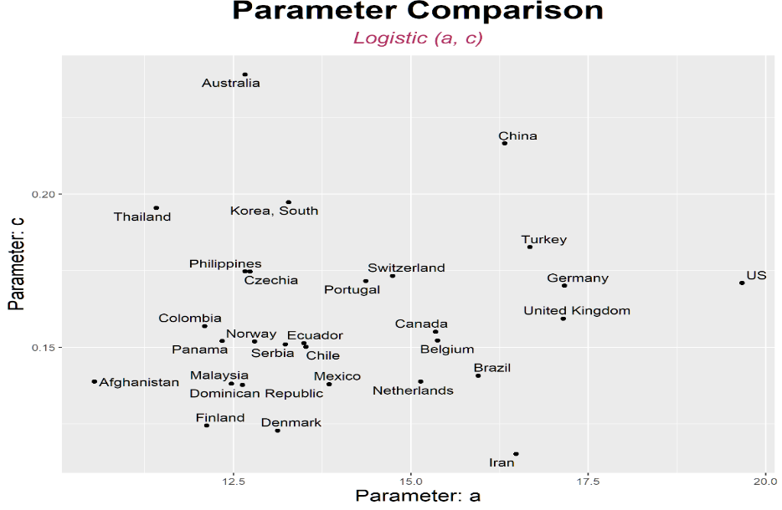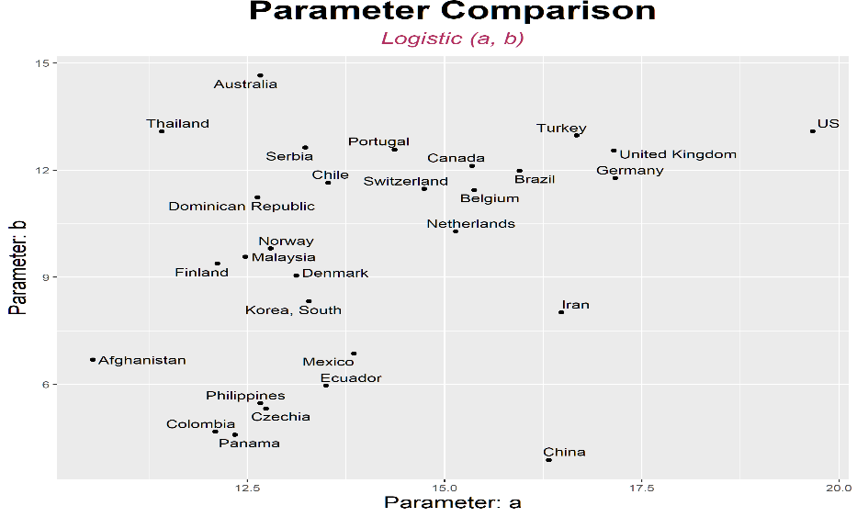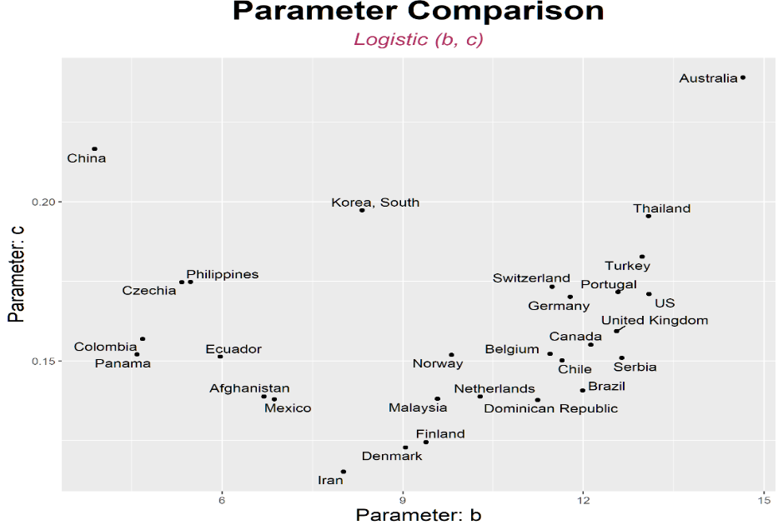

**Figure 1**. Comparison of Logistic model parameters *a*, *b*, and *c* across countries.

Using the SLR model, we explored if the selected indicators of a country’s development status have any significant relationships with parameters *a*, *b* and *c*. We observe strong and weak relationship between parameters and some indicators as shown in Table 4.

GDP per capita has both a strong and weak relationship with *b* in Logistic and Gompertz models. If *b* is large, then the time taken to the increase in the number of COVID-19 confirmed cases is delayed. Countries with higher GDP tended to have slower increase in the numbers of COVID-19 confirmed cases. GDP growth rate has a strong significant relationship with Bertalanffy model’s spread rate *b* of the pandemic in the country, and it does not show a significant relationship with the spread rate *c* of the Logistic and Gompertz models. Gross national income (GNI) has a strong positive correlation (0.811, 0.736, 0.672, 0.551) with indicators of developed countries such as human development index, life expectancy, net mobility, and urbanization. The more developed a country is, a longer time is taken to the increase in the numbers of confirmed patients. Internet has a significant though weak relationship with *b*, the time when we start to see a rise in the number of confirmed cases in the logistic model. It seems that more developed countries tend to have higher internet usage rates, which may have contributed to the weak relationship.

Savings to GDP has a strong significant relationship with the spread rate of COVID-19. Since Savings to GDP has a positive correlation with GDP (1-person GDP), human development index, and urbanization (0.428, 0.416, 0.27), we can conclude that the spread rate is faster in developed countries. National Competitiveness has a weak relationship with the expansion rate of COVID-19 pandemic. Since the relationship is weak with Bertalanffy model expansion rate *b*, it is unlikely to be useful for predicting the transmission rate. Child vaccination has a strong positive correlation (0.727, 0.688, 0.657) with indicators of highly developed countries such as human development index, life expectancy, and urbanization. Therefore, it can be inferred that vaccination of infants has an impact on the transmission rate of all the models. Pharmaceutical Sales Volume has a strong significant relationship with the maximum numbers of predicted confirmed cases. Countries with large pharmaceutical sales volume tend to have the largest number of confirmed persons cases, which may be because of large population size.

Number of international travelers has a strong significant relationship with the maximum number of predicted confirmed cases of the three models (1,2,3). Therefore, it is possible to intuitively interpret that the maximum number of confirmed patients increases as the number of foreign travelers increases. However, since both *a* and the number of international travelers is factors influenced by the population, it is necessary to correct for this effect. Number of foreign visitors has a weak significant relationship with transmission rate *c* of Gompertz model, but the coefficient is insignificant making it difficult to see that the variable is related to the transmission rate of Covid-19. Urbanization rate has a weak relationship with the *b* parameter of the logistic model. However, it has a strong positive correlation (0.784, 0.721, 0.657) with the indicators of developed countries such as human development index, life expectancy, and child vaccination.

Population density has a positive correlation (0.177, 0.147) with the indicators of developed countries (1-person GDP, human development index), and with the GDP saving rate (0.387). Therefore, the indicator shows that the more developed a country is, the faster the spread of COVID-19. Net mobility is the ratio of the difference between the number of transfers and the number of transferees divided by the total population, which has a positive correlation with the indicators of developed countries. Therefore, it is presumed that the escalation rate of the pandemic is higher in developed countries because of high net mobility rate. The aging index refers to the ratio of the population aged 65 years or older divided by the number of people under the age of 14, and we see strong significant relationship with the spread rate especially in countries with higher age groups. On the other hand, the variable has a positive correlation with GDP per person and human development index (0.693, 0.517) which may have resulted in the fast spread rate associated with developed countries.

Life expectancy has a strong positive correlation (0.921, 0.736, 0.721) with indicators from developed countries such as human development index, gross national income, and urbanization. As with child vaccination, it is thought that the more developed countries have faster the spread rate of COVID-19. Birthrate is the average number of children a woman gives birth to in her lifetime, has a strong negative correlation (-0.465, -0.809) with indicators of developed countries such as GDP per person and human development index. Therefore, it can be estimated that COVID-19 spreads faster in developed countries.

In conclusion, the more developed a country is, a longer time is taken to when the number of patients will start but after, the spread rate will be fast. Indicators for developed countries include GDP per person, human development index, and urbanization index. The reason for the late increase in the number of confirmed patients seems to be due to the well-equipped medical system. It is thought that the reason for the rapid increase is because active tests are performed according to the increase in the number of confirmed patients. Indicators such as the number of foreign travelers, the number of foreign visitors, and the net mobility rate also have an impact on the rate of spread and the increase in the number of final diagnoses.



**Table 4:** Results of the Simple linear regression analysis showing indicators with significant with parameters *a*, *b* and *c*. P-value of 0.05 is used as the cut-off point.

* 1. Between country-based Trajectory Analysis

Of the 17 policies being analyzed using the GEE model, only 3 variables had a significant relationship with the daily confirmed number of cases with p value less 0.05, namely closure of public transport, international travel controls and contact tracing (Table 5). The number of COVID-19 confirmed cases tended to decrease when public transportation was prohibited from being used or reduced in terms of travel cycles, types, routes, etc. rather than to operate as it was. There was a tendency to increase the number of COVID-19 confirmed cases as the strength of inspection and isolation for overseas travelers increased. In the case of the implemented policies corresponding to COVID-19, it is proven that the number of new confirmed persons was reduced when policies like closure of public transport and identification of entrants are implemented.



**Table 5**: Generalized Estimation Equation (GEE) model results showing p-value and coefficients of the various policies with daily confirmed covid-19 cases. 3 policies have a significant relationship with number of daily confirmed cases at p-value less than 0.05.

1. **Discussion**

COVID-19, a contact-transmissible infectious disease, is thought to spread through a population via direct contact between individuals.1,15,16 Outbreak control measures aimed at reducing the amount of mixing in the population have already been shown to mitigate the pandemic.4,5 Hellen et al, (2020) found that highly effective contact tracing and case isolation is enough to control a new outbreak of COVID-19 within three months in most scenarios.17

This paper examines the transmission dynamics of novel coronavirus disease, considering a country’s development status as a measure of selected indicator variables and the effects of government implemented policies in the mitigation of COVID-19. We used both summary statistics and trajectory analysis to carry out these investigations. The analysis showed both strong and weak significant relationships with indicator variables of development as indicated by p-values less than 0.05 for strong relationships. It is seen from Table 4, that the transmission rate of the pandemic is the most influenced transmission dynamic parameter among all the three of Bertalanffy and Gompertz models, followed by the time when we start to see a rise in the number of confirmed cases.

We observed that in more developed countries, longer time is taken for the pandemic to increase in those countries but after that, the expansion rate is rapid among the population. As for trajectory analysis, only 3 policies had a significant relationship with numbers of daily confirmed cases. All these policies involve restriction in movement of persons, so the control of movement of people is fundamental in control of the spread of the pandemic and thus a reduction in the number confirmed cases. These studies are very important for policy makers and government to make good scientific decisions while considering government resources, population dynamics and the best policies that would likely make the most impact in future prevention work against similar infectious diseases.

A key limitation of this analysis that though we fit models for forty countries, the mathematical models still produce a lot of missing parameter values due to failure of the model to converge, which affects downstream analysis and therefore, interpretation of the results. A lot is yet not known about epidemiological characteristics of COVID-19, such as individual risk factors for contracting the virus and infections from asymptotic cases. Data on the demographics and exposure history for those who have shown symptoms as well as those who have not will help facilitate these researches.

In future, we intend to extend this analysis from 40 countries to 150 countries, gain additional infrastructure for cross-border comparisons, GDP, total population, healthcare infrastructure, etc, more accurate interpretation of the Poisson regression model’s coefficient and analysis to see the importance (effect size) in addition to the significance of the effectiveness of a response policy.

**References**

1. Q Li, X Guan, P Wu, et al. Early transmission dynamics in Wuhan, China of the novel Coronavirus- infected pneumonia. N Engl J Med (2020) published online Jan 29. DOI:10.1056/NEJMoa2001316
2. WHO director-general’s opening remarks. [https://www.who.int/dg/speeches/detail/who-director-general-s-opening-remarks-at-the-media-briefing-on-covid-19-11-march-2020](https://www.who.int/dg/speeches/detail/who-director-general-s-opening-remarks-at-the-media-briefing-on-covid-19-11-march-2020" \t "_blank)
3. <https://www.worldometers.info/coronavirus/>
4. Zhang, Xiaolei, Renjun Ma, and Lin Wang. Predicting turning point, duration and attack rate of COVID-19 outbreaks in major Western countries. Chaos, Solitons & Fractals (2020): 109829.
5. Singh, Rajesh, and R. Adhikari. Age-structured impact of social distancing on the COVID-19 epidemic in India. arXiv preprint arXiv:2003.12055 (2020).
6. Hale, Thomas, et al. Variation in government responses to COVID-19. Blavatnik School of Government Working Paper 31 (2020).
7. Lin Jia, Kewen Li, Yu Jiang, Xin Guo and Ting Zhao. Prediction and analysis of Coronavirus Disease 2019 (2019)
8. <http://kosis.kr/eng/>
9. Blavatnik School of Government (University of Oxford) data. https://www.bsg.ox.ac.uk/research/research-projects/coronavirus-government-response-tracker
10. <https://github.com/OxCGRT/covid-policy tracker/blob/master/documentation/codebook.md>
11. Cheng, C., Barceló, J., Hartnett, A.S. et al. COVID-19 Government Response Event Dataset (CoronaNet v.1.0). Nat Hum Behav (2020). https://doi.org/10.1038/s41562-020-0909-7
12. Habersaat, K.B., Betsch, C., Danchin, M. et al. Ten considerations for effectively managing the COVID-19 transition. Nat Hum Behav (2020).
13. Yun Qiu, Xi Chen and Wei Shi. Impacts of social and economic factors on the transmission of coronavirus
14. disease (COVID-19) in China. medRxiv 2020.03.13.20035238. doi: https://doi.org/10.1101/2020.03.13.2003523
15. Kiesha Prem, Yang Liu, Timothy W Russell, Adam J Kucharski, Rosalind M Eggo and Nicholas Davies. The effect of control strategies to reduce social mixing on outcomes of the COVID-19 epidemic in Wuhan, China: a modelling study. The Lancet Public Health (2020). <https://doi.org/10.1016/S2468-2667(20)30073-6>.
16. J Riou, CL Althaus. Pattern of early human-to-human transmission of Wuhan 2019 novel coronavirus (2019-nCoV), December 2019 to January 2020. Euro Surveill, 25 (2020), Article 2000058
17. JFW Chan, S Yuan, KH Kok, *et al.* A familial cluster of pneumonia associated with the 2019 novel coronavirus indicating person-to-person transmission: a study of a family cluster. Lancet, 395 (2020), pp. 514-523
18. Hellewell, J., Abbott, S., Gimma, A., Bosse, N. I., Jarvis, C. I., Russell, T. W., Munday, J. D., Kucharski, A. J., Edmunds, W. J., Sun, F. et al. (2020) Feasibility of controlling covid-19 outbreaks by isolation of cases and contacts, The Lancet Global Health.
19. [Sumedha Gupta](https://www.nber.org/people/sumedhagupta) ,   [Thuy D. Nguyen](https://www.nber.org/people/thuy_d_nguyen) ,   [Felipe Lozano Rojas](https://www.nber.org/people/felipe_lozano_rojas) ,   [Shyam Raman](https://www.nber.org/people/shyam_raman) ,   [Byungkyu Lee](https://www.nber.org/people/Byungkyu_Lee) ,   [Ana Bento](https://www.nber.org/people/ana__bento) ,   [Kosali I. Simon](https://www.nber.org/people/kosali_simon) and Coady (2020) Tracking Public and Private Responses to the COVID-19 Epidemic: Evidence from State and Local Government Actions .Wing NBER Working Paper No. 27027. (DOI): 10.3386/w27027
20. Davies, N.G., Klepac, P., Liu, Y.  et al.   Age-dependent effects in the transmission and control of COVID-19 epidemics.   Nat Med   26,   1205–1211 (2020). <https://doi.org/10.1038/s41591-020-0962-9.>
21. Flaxman, S., Mishra, S., Gandy, A.  et al.   Estimating the effects of non-pharmaceutical interventions on COVID-19 in Europe.   Nature   584,   257–261 (2020). https://doi.org/10.1038/s41586-020-2405-7.

**Appendix 1**

1. National Statistics Portal (KOSIS) International Statistical Data by indicator variable.

Trade Dependence: The ratio of exports and imports to GDP. Since the correlation between export and import is very high, two averages are taken and used as new variables.

Internet usage rate: The percentage of Koreans over the age of 3 who have used wired or wireless Internet within the past month.

Savings to GDP ratio of savings to GDP.

Economic Activity Participation Rate: The proportion of the economically active population, including the unemployed and the unemployed, among the population aged 15 and over.

Annual average temperature, annual average precipitation: 30-year statistics from 1961 to 1990 based on observed temperature and precipitation.

GDP per capita: Gross domestic product divided by the number of people.

GDP growth rate: The rate of increase of gross domestic product over the previous year.

Gross national income: The sum of income earned by people in a country in exchange for participating in production activities. The income received by foreigners (residents) from overseas (foreign income factor income) is included, while the income paid to foreigners (non-residents) from the gross domestic product (foreign factor income) is excluded.

Overseas Travelers: The number of foreign tourists with Korean nationality is processed by the Ministry of Justice's national departure statistics.

Foreign Visitors: The number of foreign visitors to Korea is calculated based on the immigration statistics of the Immigration Office of the Ministry of Justice.

Population Development Index: The average of the income index, life expectancy index, and education index (calculated from the rate of adult character reading and school enrollment).

National Competitiveness: The ranking of national competitiveness announced by the Swiss Institute of International Business Development (IMD). Consider areas such as economic performance, government efficiency, corporate efficiency, and infrastructure.

Infant Immunization Rate: The infant immunization rate is the percentage of infants 12 to 23 months of age who were vaccinated 12 months before or before the investigation of four diseases, measles and DPT (diphtheria, whooping cough, tetanus).

Malnutrition Population Ratio: Percentage of the population who consistently consume food at a level lower than the minimum dietary energy consumption.

Public social welfare expenditures: social benefits or financial assistance by public institutions while households or individuals are in a disadvantaged environment. Expressed as a percentage of GDP.

The frequency of tuberculosis: The number of tuberculosis cases per 100,000 people.

Drug Sales: Total sales based on the retail price of the drug's final sales, classified by ATC code (Anatomical Therapeutic Chemical Classification System).

Urbanization rate: The proportion of the population living in urban areas among the total population. However, the concept of cities in each country is different, and the urban population of each country is based on the census of each country.

Population density: The number of people in a given area divided by the area of ​​the given area. Usually expressed as population per ㎢.

Net moving rate: The number of the number of transferees minus the number of transferees over a specific period divided by the total population of the period.

Major Cities Population: The actual number of people living in the regions classified as cities according to each region or country.

Aging index: (Population over the age of 65 in the current year ÷ Population between 0 and 14 in the current year) × 100.

Life Expectancy: The average number of years a 0-year-old is expected to survive in the future.

Total fertility rate: Average of the number of children a woman has in her lifetime